Chapter 15698861

Using the projector
Preparations of the projector 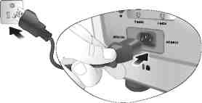

- Plug in all cables.
- Plug the supplied power cable into the AC inlet on the rear of the projector.
- Plug the power cable into a power outlet

Chapter 2655132197

Turning the projector on

- Plug in all cables.
- Plug the supplied power cable into the AC inlet on the rear of the projector.
- Plug the power cable into a power outlet.

Please do not use extension cable longer than 2.5 metres.

All supplied cables are certified by ISO.

